# **Laboratory-1**

## **QUESTION-1**

## Build a lexical analyser that ignores white spaces & comments.

%{

#include <stdio.h>

#include <string.h>

%}

%%

\n?"/*"(.|\n)*"*/"\n ;

"//".*\n ;

[ ]+ {fprintf(yyout," ");}

[\t]+ {fprintf(yyout,"**\t**");}

[\n]+ {fprintf(yyout,"**\n**");}

. ECHO;

%%

int main()

{

yyin = fopen("sample.c","r");

yyout = fopen("cleaned.c","w");

yylex();

fclose(yyout);

fclose(yyin);

return 0;

}

int yywrap()

{

return 1;

}

**Input (sample.c):**

#include<stdio.h>

**int** main()

{

printf("Hello"); // first hello

/*

Let's try multi line comments

now

here

*/

printf("Welcome to LEX tool !");

}

**Output (cleaned.c):**

#include<stdio.h>

**int** main()

{

printf("Hello");

printf("Welcome to LEX tool !");

}

**Result**: The white space and comment ignoring lex code has been implemented successfully.

## **QUESTION-2**

## Build a lexical analyser to analyse keywords and identifiers in C.

%{

#include<stdio.h>

#include<string.h>

%}

%%

**if**|**for**|**while**|**else**|**do**|**int**|"long long"|**short**|**float**|**double**|include|main|**return**|printf|"<stdio.h>" {printf("keyword %s \n",yytext);}

[_a-zA-Z$][_a-zA-Z0-9]* {

**if**(yyleng <= 32){

printf("identifier %s \n",yytext);

}

**else**{

printf("Identifier size exceeded the max length\n");

}

}

[0-9]+ {

**if**(yyleng < 10 || (yyleng == 10 && yytext < "2147483648")){

printf("Numeric value %s \n",yytext);

}

**else**{

printf("Numeric value exceeded INT_MAX\n");

}

}

. ;

%%

**int** yywrap(){

**return** 1;

}

**int** main(){

yyin = fopen("sample.c","r");

yylex();

fclose(yyin);

**return** 0;

}

## **Input (sample.c):**

#include <stdio.h>

**int** main()

{

**int** a = 5;

**if**(a > 0)

{

**while**(a--)

printf("Good Day\n");

}

**else**

{

**for**(**int** i=0;i<a;i++)

printf("May Day\n");

}

printf("Hello");

**return** 0;

}

## **Output:**

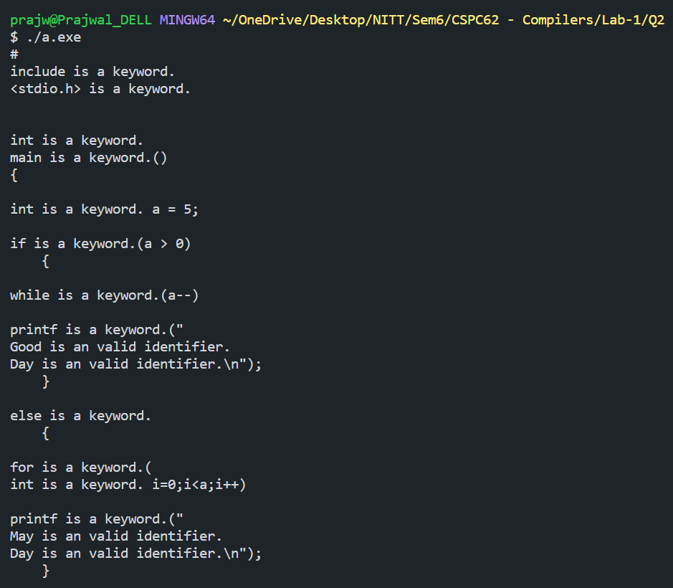

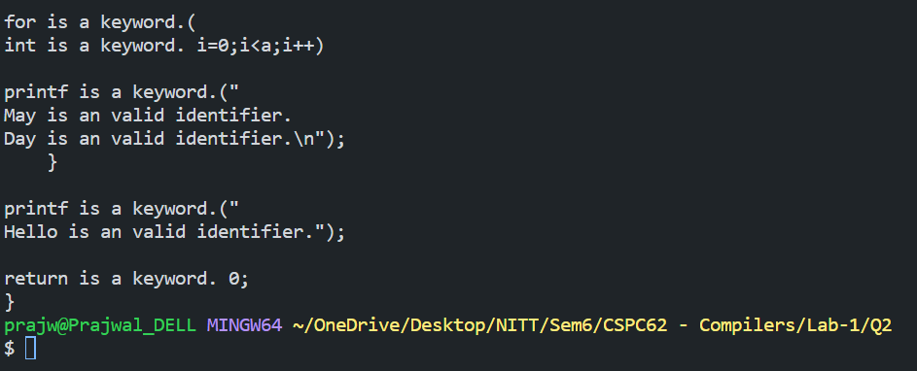

## **Result:**

The keywords and identifiers analysing lex code has been implemented successfully.

## **QUESTION-3**

## Build a lex program for identifying operators in C.

%{

#include<stdio.h>

#include<string.h>

%}

%%

">" {printf("Greater Than >\n");}

"<" {printf("Lesser Than <\n");}

"=" {printf("assigning =\n");}

"+" {printf("Addition +\n");}

"-" {printf("Subtraction -\n");}

"/" {printf("Division /\n");}

"*" {printf("Multiplication *\n");}

"%" {printf("Modulo %%\n");}

"!=" {printf("Not equal !=\n");}

"==" {printf("Comparision ==\n");}

">=" {printf("Greater Than equals to >=\n");}

"<=" {printf("Greater Than equals to <=\n");}

. ;

%%

**int** yywrap(){

**return** 1;

}

**int** main(){

yyin = fopen("sample.c","r");

yylex();

fclose(yyin);

**return** 0;

}

## **Input (sample.c):**

#include<stdio.h>

**int** main() {

**int** a;

printf("Hello world");

**int** x = 5, y = 7;

}

## **Output:**

### 

## **Result:**

Lex Code to analyse relational operators has been implemented successfully.